

Department of Computer Information Systems

King Abdullah II School for Information Technology

The University of Jordan

Information Technology Entrepreneurship Innovation (1902383)

Standard

PROPOSAL

BRT Road Cameras

Faster and Safer

Group member |ID

Mohammad Roshdi Khatatbeh 0189721

Tsneem Abdeljaleel Alzboon 0192212

Ayat Mohammad Alsheikh 0195384

Zaid Mazen Aburasheid 0206186

Dina AL Alawneh 0187733

Table of Contents

1.Summary…………………………………………………………………………………………………………………………………3

2.Objectives………………………………………………………………………………………………………………………..……..3

3. Beneficiaries 4

4.Impact summary 4

5.Businnes model 5

6. Summary of Resources Required for Project 6

7. Project’s Budget 6

8. Justification of resources 6

9.Methodology 7

10. Project’s Timeline 8

11.Project’s Team 8

12.Project Customers 8

13.Funding Opportunities 8

14.References 9

15.Video link 9

1.Summary

Are you searching for the best transport way in Jordan?

After lunching Bus rapid transit (BRT) project in 2021 it served thousands of citizens during last year, but some people complained about some issues that they faced during using this transport system such as safety, availability, and the late arrival.

So, we had thought for a solution for those problems to make the (BRT) more efficient by using cameras beside the traffic lights that are in the bus route and connect them to an AI system to control the traffic lights, do some calculations and for monitoring. and with an application to provide the passengers with useful information.

This will improve the level of the BRT performance to become the best transport system you can use.

2. Objectives

* AI system connected with cameras will detect the bus from long distention and it will give access and priority for the bus by turning other path traffic lights to red before the bus arrive, so it won’t need to waste time on stopping on road intersections.
* Al system will detect the number of passengers in the bus and the bus speed on the road that will alert the system if there are any violations for safety guarantee.
* Improving availability: the cameras will do some calculations by detecting the number of the passengers in every path to provide the path with right number of vehicles it needs.
* Application service connected with the cameras for tracking nearest bus and nearest riding points to the user.

# 

# 3. Beneficiaries

**Passenger**: It’s all about making the passenger reach his destination safely and as fast as possible so the more efficient the BRT is the more passenger will use the bus .

**Government**: when the project works more efficient more citizens will use it and that will increase the revenue.

**The traffic**: more citizens will use the BRT instead of their cars to save time, and by applying the full control of the traffic lights it will make the traffic move faster.

# 4.Impact summary

Lately the population number in Jordan is growing so fast in the last 10 years because of the immigrants and the born rate and this huge number of people in a small city like Amman has made traffic issues that effected our life in so many ways, people are getting so late for their jobs, schools, and collages because of the slow flow of the traffic.

So, we must decrease the number and the usage of the vehicles on the roads, But how?

After the BRT improvement we have to persuade people for using the BRT instead of using their cars to go to the daily rides by posting the benefits of using the bus instead of their cars and how this will affect their time and will cost less money and will make less population and much more.

It’s the time for the BRT to become the first transport system used in Jordan.

# 5.Businnes model

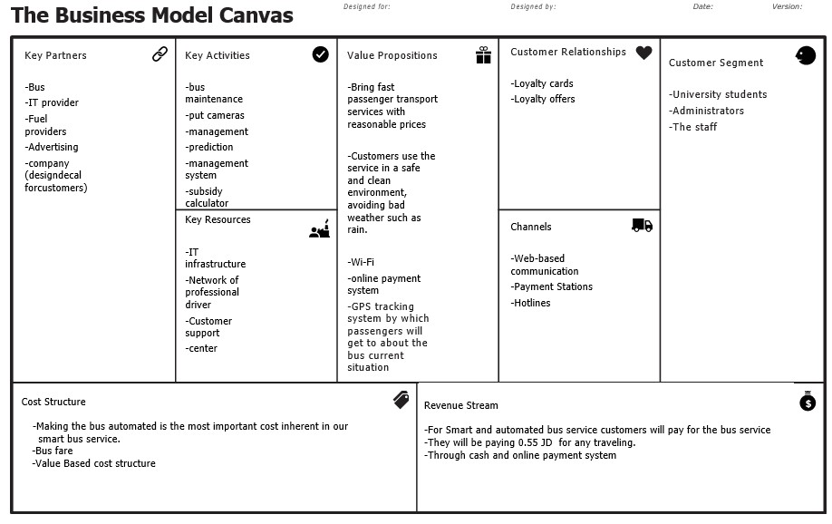

# 6. Summary of Resources Required for Project

**Required resources**

Smart Cameras: used on the traffic lights that is connected to the AI system

AI system: do some calculations and detections

More buses: AI will count the need for each track

Staff: AI programmer, engineers, bus drivers.

control offices: watch the AI system workflow.

# 7. Project’s Budget

|  |  |
| --- | --- |
| **Required resources** | **Price** |
| Smart cameras | $15000 |
| Ai system | $2000 |
| Buses | $10000 for each |
| Staff | $500 per month for every employee |
| Control offices | $400 per moth |

# 8. Justification of resources

**Cameras** are needed at every traffic light in the Bus Road to provide the AI system that is connected to with the information needed.

**AI system** that is connected to the cameras will do calculations, monitoring, recognition, and control the traffic lights.

**Staff** will help in programming the system, connect the AI with cameras, camera installation, daily checking out and repair.

**Extra buses** for meeting people need.

**Control offices** we can’t fully trust the Ai, so we need control offices to monitor the whole process.

# 9.Methodology

|  |  |  |  |  |  |  |  |  |
| --- | --- | --- | --- | --- | --- | --- | --- | --- |
| Name | Work  package | Priority | budget | description | status | Directed  path | Potential | Step |
| Mohammed | Programming | High | 2000 | Develop a full functional system | Open | None | High | 1 |
| Zaid | Leading and logistics | High | 500 | Making it familiar with funding agencies | Open | Government | High | 2 |
| Tsneem | Marketing and word spreading | High | 500 | Attract citizens | Open | Feedback to office | High | 3 |
| Ayat | Customer  care | High | 500 | Helping to have loyal and a happy client | Open | Feedback to office | High | 4 |

# 10. Project’s Timeline

# 11.Project’s Team

|  |  |
| --- | --- |
| Mohammad Roshdi Khatatbeh | 20% (with his go to coding skills his is needed in coding) |
| Zaid Mazen Aburasheid | 20% (organizing and implementing the idea with his background in transportation system) |
| Tsneem Abdeljaleel Alzboon | 20% (with her ability to sell thin air he can take over marketing) |
| Ayat Mohammad Alsheikh | 20% (with her ability to work loads of hours in the customer care sector) |
| Dina AL alwaneh. | 20% (with her accounting skills to calculate the budget and the revenue.) |

# 12.Project Customers

All the citizens that need to transport around the city

# 13.Funding Opportunities

Government will be the main supporter to improve their BRT project and solve the traffic problem

Transport companies (JET) they may support the project with the buses that they have

# 14.References

<https://medium.com/seed-digital/how-to-business-model-canvas-explained-ad3676b6fe4a>

http://www.ammanbrt.jo/

# 15.Video link